**Building an Advanced FM Radio with Arduino Nano, RDA5807M, LCD1602, and TTP223 Touch Switches**

**Components Required:**

1. **Arduino Nano**
2. **RDA5807M FM Radio Module**
3. **LCD1602 Display (I2C or Parallel)**
4. **4 x TTP223 Touch Switches**
5. **Speaker (with amplifier if needed)**
6. **Wires & Breadboard**
7. **Power Source (USB or external 5V supply)**

**Wiring Diagram:**

**1. RDA5807M to Arduino Nano**

| **RDA5807M** | **Arduino Nano** |
| --- | --- |
| VCC | 3.3V |
| GND | GND |
| SDA | A4 (SDA) |
| SCL | A5 (SCL) |

**2. LCD1602 to Arduino Nano (I2C Version)**

| **LCD1602 (I2C)** | **Arduino Nano** |
| --- | --- |
| VCC | 5V |
| GND | GND |
| SDA | A4 |
| SCL | A5 |

**3. TTP223 Touch Switches**

| **TTP223 (Mode: Active High)** | **Arduino Nano** |
| --- | --- |
| VCC | 5V |
| GND | GND |
| OUT 1 (CH+) | D2 |
| OUT 2 (CH-) | D3 |
| OUT 3 (VOL+) | D4 |
| OUT 4 (VOL-) | D5 |

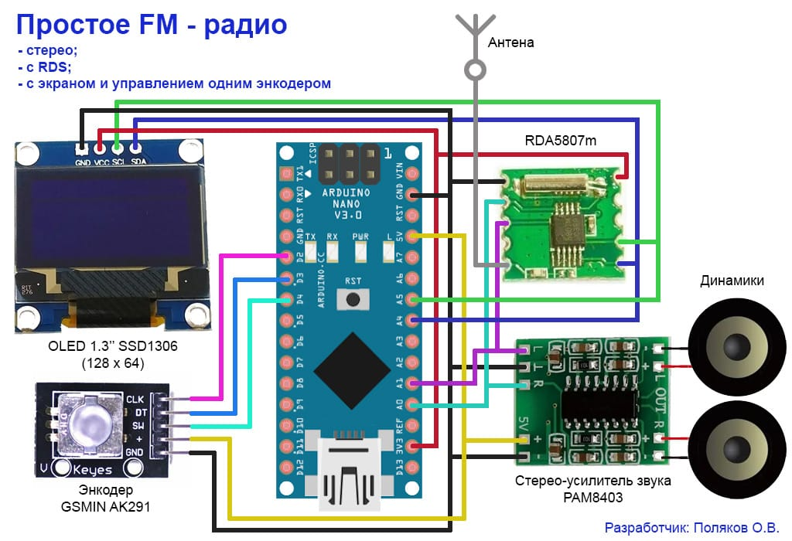**4. Speaker (with amplifier)**

| **Amplifier** | **Arduino Nano** |
| --- | --- |
| Audio In | RDA5807M Audio Out |
| GND | GND |
| VCC | 5V |

**How to Use**

1. **Short Press:** 
   * **Tune Up (D2): Increases frequency by 0.1 MHz.**
   * **Tune Down (D3): Decreases frequency by 0.1 MHz.**
   * **Volume Up (D4): Increases volume (if pressed for less than 3 seconds).**
   * **Volume Down (D5): Decreases volume (if pressed for less than 3 seconds).**
2. **Long Press (3 seconds):** 
   * **Volume Up (D4): Moves to the next preset station.**
   * **Volume Down (D5): Moves to the previous preset station.**
3. **Display:** 
   * **First row: Always shows the current frequency (e.g., "Freq: 91.9 MHz").**
   * **Second row: Shows the station name if a preset is selected (e.g., "Friends FM"), or the volume level if manually tuned (e.g., "Vol: 8").**